|  |  |
| --- | --- |
| glenegl2 (mac) | **School District #43, Coquitlam**  **1195 Lansdowne Drive**  **Coquitlam, B.C. V3B 7Y8**  Telephone (604) 464-5793 Fax (604) 464-5796 |

**P L E D G E F O R M** 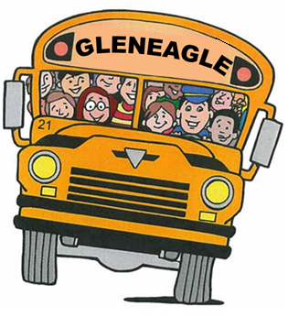

**Donor information (please PRINT clearly or type)**

|  |  |
| --- | --- |
| Name |  |
| Billing Address |  |
| City |  |
| Postal |  |
| Telephone (Home) |  |
| Telephone (Business) |  |
| Fax |  |
| E-Mail |  |

**Pledge Information**

I (we) pledge a total of $ ______________ to be paid:

|  |  |  |  |
| --- | --- | --- | --- |
| $___________ now | $ ___________ monthly | $ ___________ quarterly | $ ___________ yearly |

|  |  |  |  |  |  |  |  |  |  |  |  |  |  |  |  |  |
| --- | --- | --- | --- | --- | --- | --- | --- | --- | --- | --- | --- | --- | --- | --- | --- | --- |
| **Credit Card Type** | **Visa Master Card American Express** | | | | | | | | | | | | | | | |
| **Credit Card Number** |  |  |  |  |  |  |  |  |  |  |  |  |  |  |  |  |
| **Expiration Date;** | **Month:** | | | | | | | | **Year** | | | | | | | |
| **Authorized Signature:** |  | | | | | | | | | | | | | | | |

**Acknowledgement Information**:

Please use the following name (s) in all acknowledgment:

____________________________________________________________________

____________________________________________________________________

**I (we) wish to have our gift remain anonymous.**

**________________________ ________________________**

Signature(s) Date

Gleneagle School Bus Campaign

**TAX RECEIPTS WILL BE ISSUED AUTOMATICALLY FOR $25.00 OR MORE**